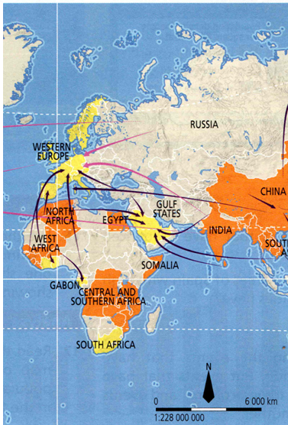
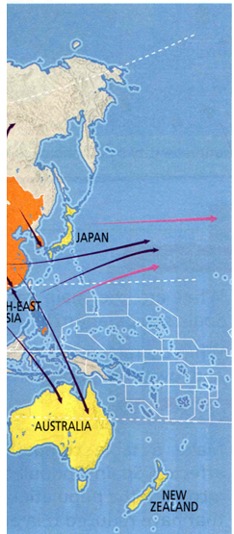
C
B
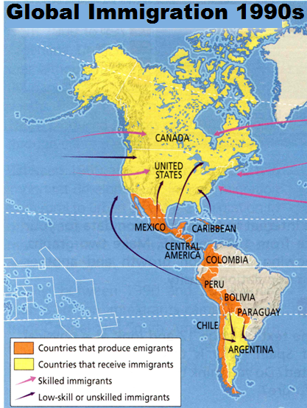
A
Migration: the movement of people from one location to another to settle temporarily or permanently
Migrant: people who make a conscious choice to leave their country to seek a better life elsewhere
Emigrants: people who leave their country of origin
Immigrants: people who enter a country that is not their place of origin
Duration: 1) temporary (seasonal) migrants (agricultural workers or summer tourists)
Causes: economic reasons to find work, pursue a particular career, famine, war, persecution for political, religious and ethnic reasons

Answer the following questions with your group:

Who do you know who has migrated to another country?
When do migrant workers usually come to your part of the world?
What is the duration of migrant workers in the fields in your part of the world?
Why do more people you know not work in the fields? What is the cause of farmers near you hiring emigrants instead of their neighbours?

