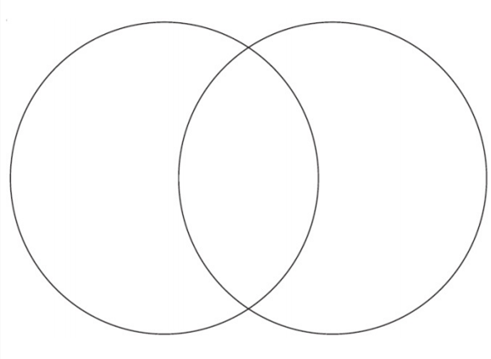



Introducing Multiplication

5+5+5+5 = 20

4 x 5 = 20

5 x 4 = 20

3 x 5 = 15

4 x 6 = 24

6 x 4 = 24

3 x 9 = 27

9 + 9 + 9 = 27

3+3+3+3+3+3

+3+3+3 = 27

4+4+4+4+4+4 = 24

6 + 6 + 6 + 6= 24

5 + 5 + 5 = 15

3+3+3+3+3 = 15

4+4+4+4+4 = 20

5 x 3 = 15

3 x 9 = 27

20

24

15

27