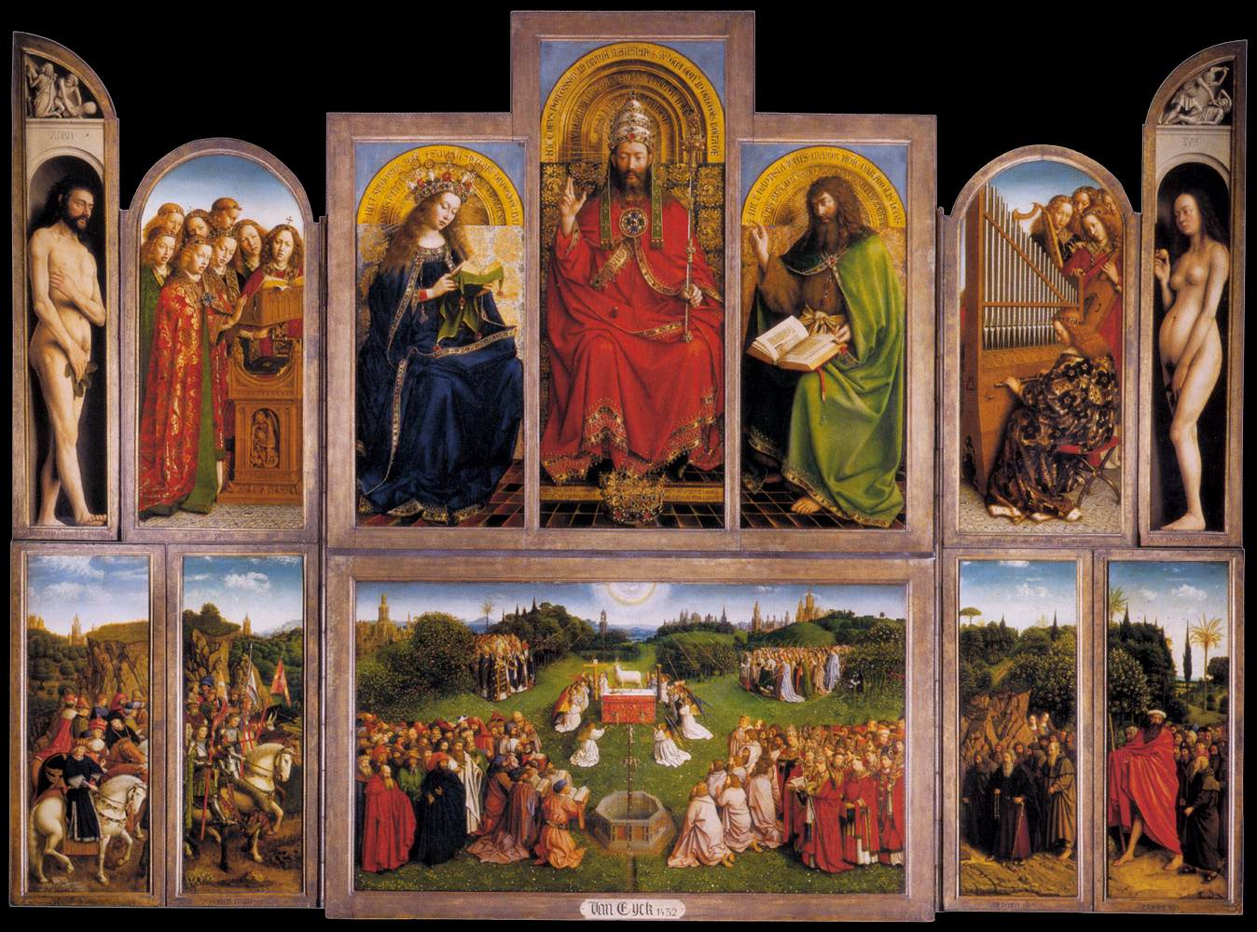

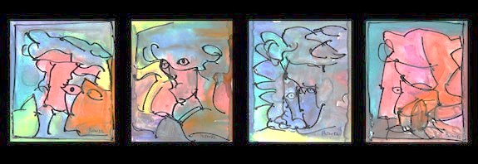
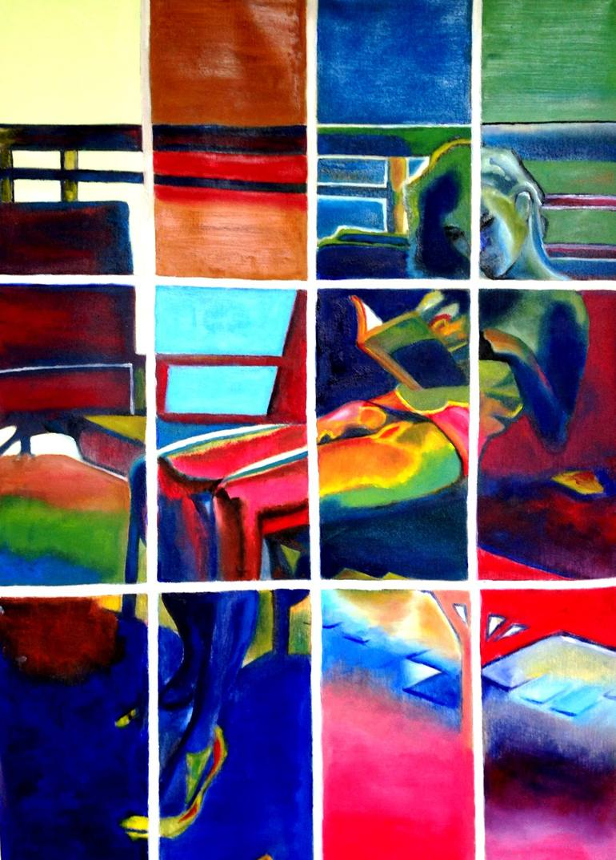
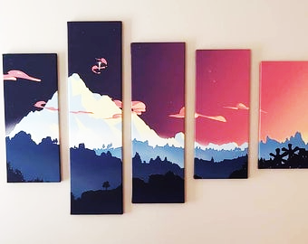
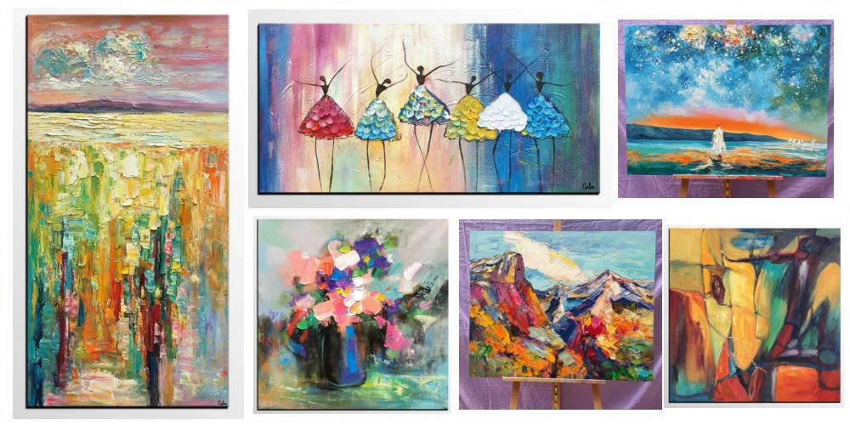
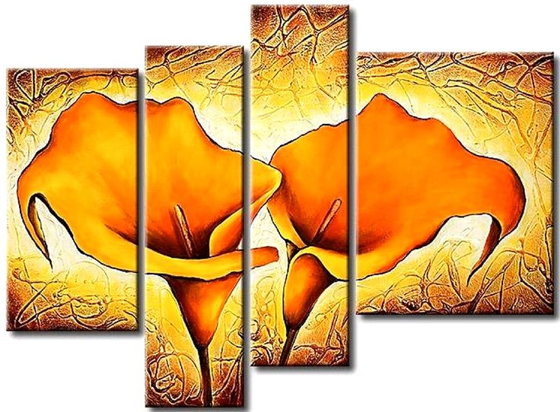
.

A polyptych is a painting (usually panel painting) which is divided into sections, or panels.

Historically, polyptychs typically displayed one "central" or "main" panel that was usually the largest of the attachments; the other panels are called "side" panels, or "wings".

A polyptych is an altarpiece consisting of more than three panels, set with paintings or carvings, and usually hinged for folding.

A polyptch , more specifically a"diptych" is a two-part work of art; a "triptych" is a three-part work; a tetraptych or quadriptych has four parts, and so on.

A pentaptych is a polyptch with 5 parts; hexaptych describes 6 parts; heptaptych describes 7 parts; and octaptych is the term used for an eight-part, or eight-panel, work of art

A polyptych is a work of art, as a painting, that has several panels.

A polyptch is a painting made up of more than three panels.

A polyptych is a painting (usually panel painting) which is divided into sections, or panels.

A polyptych is a painting (usually panel painting) which is divided into sections, or panels. Specifically, a "diptych" is a two-part work of art; a "triptych" is a three-part work; a tetraptych or quadriptych has four parts, and so on.

Historically, polyptychs typically displayed one "central" or "main" panel that was usually the largest of the attachments; the other panels are called "side" panels, or "wings". Sometimes, as evident in the Ghent and Isenheim works, the hinged panels can be varied in arrangement to show different "views" or "openings" in the piece. The upper panels often depict static scenes, while the lower register, the predella, often depict small narrative scenes.

Polyptychs were most commonly created by early Renaissance painters, the majority of whom designed their works to be altarpieces in churches and cathedrals. The polyptych form of art was also quite popular among ukiyo-e printmakers of Edo period Japan.

Some medieval manuscripts are polyptychs, particularly Carolingian works, in which the columns on the page are framed with borders that resemble polyptych paintings.

Final Task: (making the information visible)
Water colour polypytch 6-8 paneled painting that includes:

- 1 panel showing reconstructed homesite
- 1 panel general map of where your new home is located
- 1 panel showing agricultural area for your cultivation
- 1 panel showing a detailed flowering plant that grow in this environment
- 1 panel showing a detailed conifer that grows in this environment
- 3 panels of your choice (answering parts of the Enquiry Question)
- 100-150 word answer to the Enquiry Question
- a digital image of your finished polyptych painting with explicative captions of each panel
- a 100-150 word critique from 'a famous art critic', giving definition of polyptych art, an evaluation of your polyptych painting, and whether your final task agrees with the criteria of polyptych art
- a recording of each member in the group verbalising one element of your group's process in collectively answering and completing the project

