UNIVERSITY - ENGINEERING (Construction materials)

Concrete resists compression and with _____ rebar frameworks it can also bear traction.
Pneumatic structures are light and easy to _________, set up, and dismantle.
Spatial and geodesic structures are three-dimensional that combine the properties of ________ with triangulated structures.
The curved shape and folds of __________ structures give them their strength.
Concrete resists compression and with steal rebar frameworks it can also bear traction.
_________________ structures are light and easy to transport, __________ and dismantle.
______________ and geodesic structures are three-dimensional that combine the properties of vaults with triangulated structures.
The curved shape and folds of laminated structures give them their strength.

___________ resists compression and with steal rebar frameworks it can also bear traction.
Pneumatic _________ are light and easy to transport, set up, and dismantle.
Spatial and ____________ structures are three-dimensional that combine the properties of vaults with triangulated structures.
The _________ shape and folds of laminated structures give them their strength.
Concrete resists __________ and with steal rebar frameworks it can also bear traction.
Pneumatic structures are light and easy to transport, set up, and _________.
Spatial and geodesic structures are three-dimensional that combine the properties of vaults with __________ structures.
The curved shape and folds of laminated structures give them their __________.

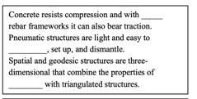
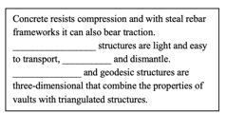
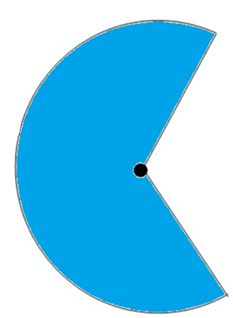
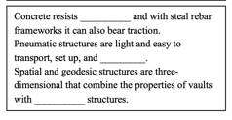
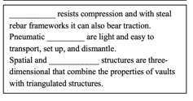

Concrete resists compression and with steal rebar frameworks it can also bear traction.
_________________ structures are light and easy to transport, __________ and dismantle.
______________ and geodesic structures are three-dimensional that combine the properties of vaults with triangulated structures.
The curved shape and folds of laminated structures give them their strength.
Concrete resists __________ and with steal rebar frameworks it can also bear traction.
Pneumatic structures are light and easy to transport, set up, and _________.
Spatial and geodesic structures are three-dimensional that combine the properties of vaults with __________ structures.
The curved shape and folds of laminated structures give them their __________.
___________ resists compression and with steal rebar frameworks it can also bear traction.
Pneumatic _________ are light and easy to transport, set up, and dismantle.
Spatial and ____________ structures are three-dimensional that combine the properties of vaults with triangulated structures.
The _________ shape and folds of laminated structures give them their strength.
Concrete resists compression and with _____ rebar frameworks it can also bear traction.
Pneumatic structures are light and easy to _________, set up, and dismantle.
Spatial and geodesic structures are three-dimensional that combine the properties of ________ with triangulated structures.
The curved shape and folds of __________ structures give them their strength.
