Here; wear this jewel for me; 'tis my picture:
Refuse it not; it hath no tongue to vex you;
And I beseech you come again tomorrow
What shall you ask of me that I'9ll dey,
That honour saved may upon asking give?

- ______________ says these lines.
- ______________ says these lines to ______________
- At this point in the play, this is happening:
______________________________
______________________________
______________________________

This is an image of at least one thing that is happening in the play at this point:
What relish is in this? How runs the stream?
Or am I mad, or else this is a dream.
Let fancy still my sense in Lethe steep;
If it be thus to dream, still let me sleep.

- ______________ says these lines.
- ______________ says these lines to ______________
- At this point in the play, this is happening:
______________________________
______________________________
______________________________

This is an image of at least one thing that is happening in the play at this point:
By my life, this is my land's hand! These be her very C's, her U's and her T's; why that?

- ______________ says these lines.
- ______________ says these lines to ______________
- At this point in the play, this is happening:
______________________________
______________________________
______________________________

This is an image of at least one thing that is happening in the play at this point:
I prithee, and I'll pay thee bounteously,
Conceal me what I am, and be my aid
For such disguise as haply shall become
The form of my intent. I'll serve this duke;

- ______________ says these lines.
- ______________ says these lines to ______________
- At this point in the play, this is happening:
______________________________
______________________________
______________________________

This is an image of at least one thing that is happening in the play at this point:
Answers:

Viola:

I prithee, and I'll pay thee bounteously,
Conceal me what I am, and be my aid
For such disguise as haply shall become
The form of my intent. I'll serve this duke;

Act One, Scene 2

Malvolio:

By my life, this is my land's hand! These be her very C's, her U's and her T's; why that?

Act Two, Scene 5

Olivia:

Here; wear this jewel for me; 'tis my picture:
Refuse it not; it hath no tongue to vex you;
And I beseech you come again tomorrow
What shall you ask of me that I'9ll dey,
That honour saved may upon asking give?

Act Three, Scene 4

Sebastian:

What relish is in this? How runs the stream?
Or am I mad, or else this is a dream.
Let fancy still my sense in Lethe steep;
If it be thus to dream, still let me sleep.

Act Four Scene 1

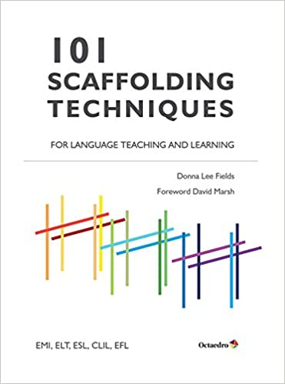

amazon.com

