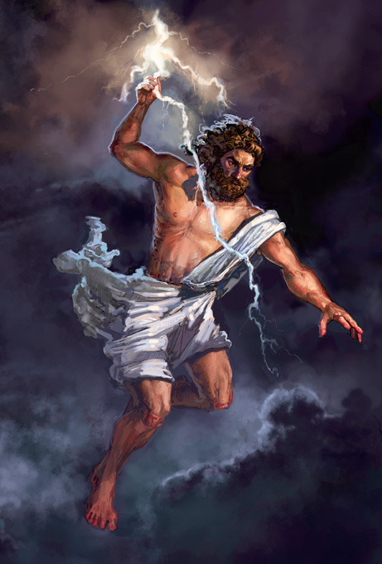

'Father, I am your son!'
'Rise Phaethon. Let me look at you.'
Yes, you may well be my son. Clymene's boy. I remember your mother well. How is she?'
.

'Well, you're my son, all right. Speak up then. What is it you wish? I will do anything in my power to help you. I swear by the river Styx, an oath sacred to the gods.'

Zeus looked upon the earth. He saw the dead and the dying. He saw that Apollo was not driving the chariot. He stood up, drew back his arm, and hurled a thunderbolt.

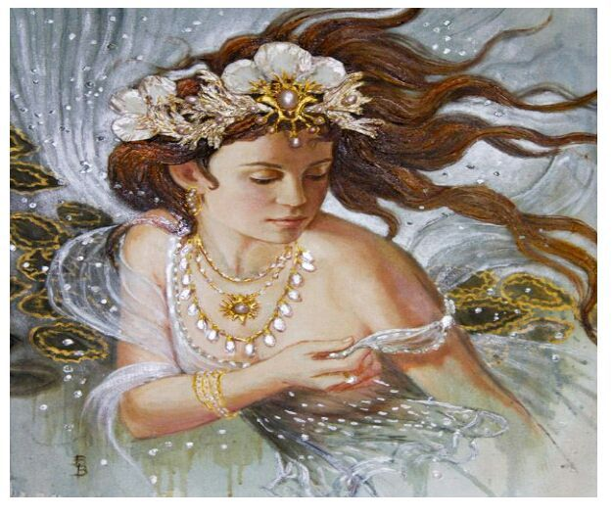
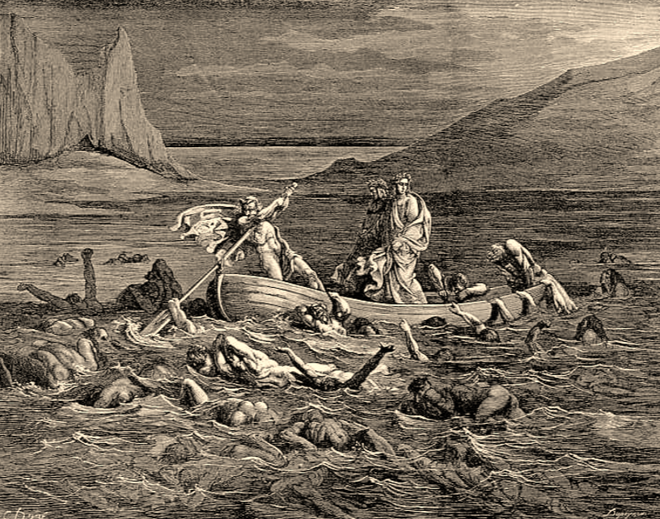

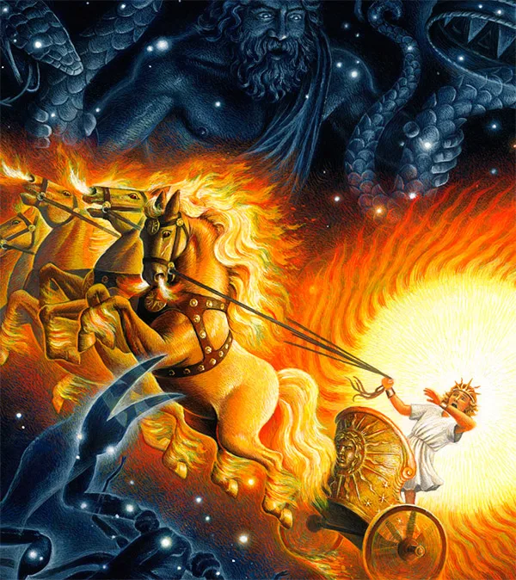
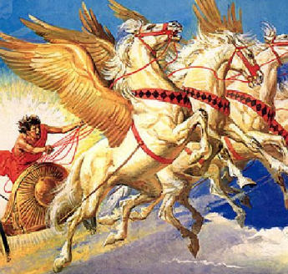
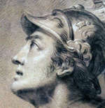

'My father is the chief god, king of the mountain, lord of the sky', said Epaphus. I don't believe there is a sun chariot, and I don't believe your father lets you drive it.'

Phaethon jerked on the reins, pulled the horses' heads down. They whinnied angrily and tossed their heads. He jerked the reins again. 'Down! Down!' he cried.

Phaethon could not hold his horses, and still they galloped upward dragging light and warmth away from the earth. Phaethon was gasping for breath.
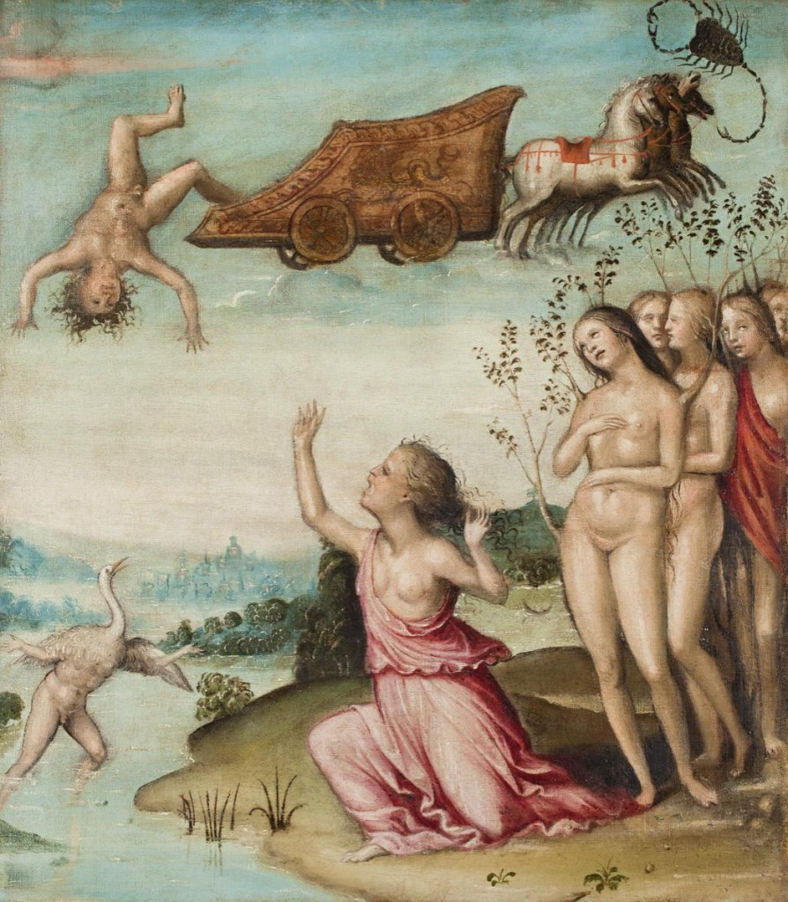
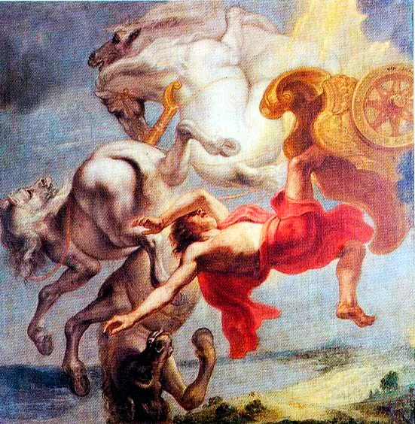
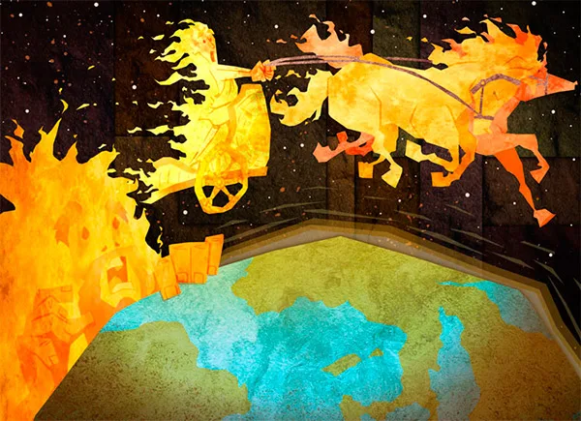

Phaethon's sisters grieved for the beautiful boy. They could not stop weeping. They stood on the bank of the river, until, unable to comfort them, Zeus changed them to trees.

It stabbed through the air, striking Phaethon, killing him instantly, knocking him out of the chariot. The horses of the sun, galloped homeward toward their stables.

Phaethon could not see. He had unbound the reins from his wrists. He had no control over the horses at all. They galloped upward again - out of the steam.

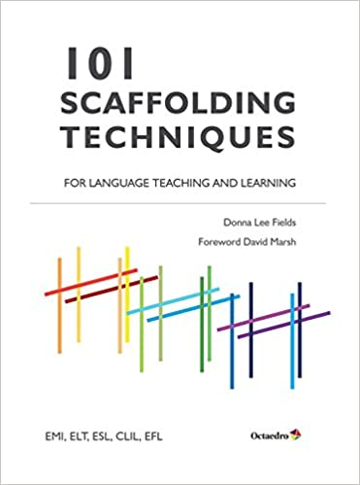

amazon.com

