

theory behind the scaffold…

Adding humour to a lesson is always a recipe for success. Humour changes the dynamic of the class and helps students to see their lessons from a different frame of mind. This scaffold uses irony to help make potentially dry material more inviting and accessible - irony being the highest form of humour.

Humour is very cultural. American humour, for instance, is binary and is either present or absent. In the Far East, on the other hand, one encounters a wide spectrum of subtle degrees of humour that are commonly present.* In cultivating global citizens, it is important that our students know the differences of humour in different cultures – between irony and simpler forms of humour - so that they can react to it appropriately. It’s yet another way of getting to know the people around us in this interconnected world.

On a more colloquial level, humour brings enthusiasm, positive feelings and optimism to the classroom. Irony generates cognitive activity and changes the dynamic of the class. Using humour and irony in conscientious ways will help students to see their lessons from a different frame of mind; once they are more relaxed, you can have more meaningful verbal exchanges about the topic at hand and assimilate new information more deeply.

In putting this activity together, you'll have the opportunity to have fun with language. You'll prepare questions from a lesson, unit, or project your students are about to begin. Each question will include multiple choice answers - one that is most appropriate, and the rest as absurd as you like them to be.

You can begin by telling your students that you're going to give them a short quiz. Enjoy - very briefly t- heir groans, knowing that they are going to start laughing very soon. As their amusement rises, so will their receptivity of new concepts and language.

*Hall, Edward T. (1973). The Silent Language. New York. Anchor Books

Scaffolding with Irony (Primary)
Donna Lee Fields, Ph.D.

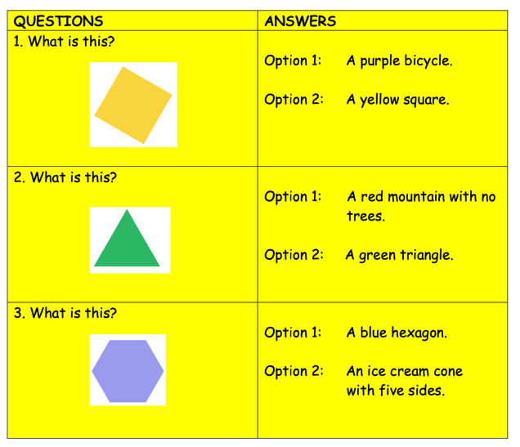
(Example of at multiple choice quiz, of a natural science lesson.)

Step by Step:

- Write 10-15 questions related to the unit you’re about to begin. For each question, offer multiple choice answers - one appropriate and the others written with irony (to the point of being absurd).

- To make the activity cooperative, give one copy of the 'quiz' to each group of students. The Speaker reads the questions and the three possible answers aloud. The other group members take turns a) identifying the most appropriate answer, and b) explaining why another one cannot be appropriate. The Moderator keeps the group interacting in an efficient manner, with everyone having a chance to participate. (See example of a below using maths.)

- The activity continues until all the questions have been asked and answered in the manner outlined above.

- Finish by going over the quiz as a class, with each Speaker taking turns asking the questions and each group taking turns answering. As each group answers, you ask another group if they agree with the answer or not, and they must give their response in a complete sentence. (Ex. 'Yes, we agree with the answer because the other two options were not appropriate.' or 'No, we don't agree with the answer. We believe the answer is 'b' _____________.')

- Formative Assessment: Project the questions on the white board and each group has takes turns answering, without the aid of the sheets they worked with during the activity.

- Reflection: Students write 7-10 sentences on the dynamic. They comment on whether it was important for them to both speak and listen during the activity. They comment on the humour and whether that changed their mood towards learning the new information.

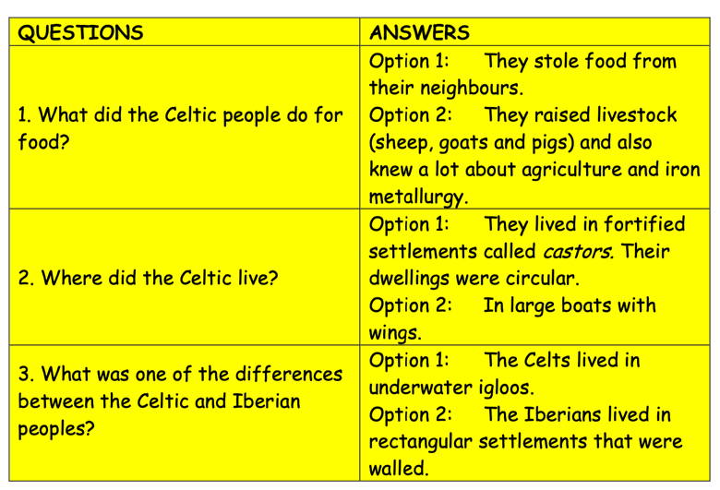

Using humour to scaffold geometry)

video explanation…
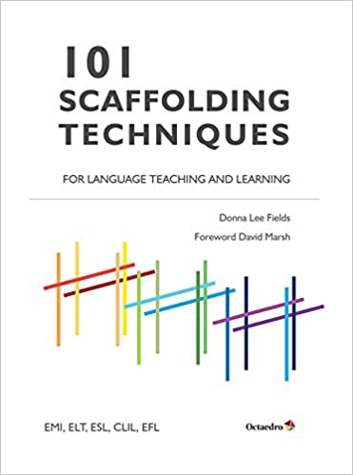
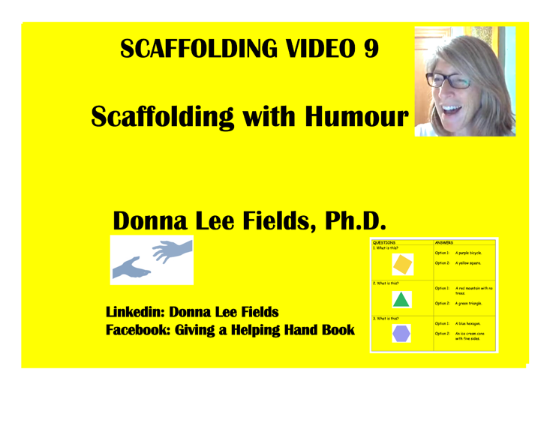

amazon.com
transcript of video…

Hi, I'm Donna Fields and welcome to CLIL Scaffolding 9. It's a series of webinars designed to help give you support for using scaffolding in your lessons. Today we're going to use scaffolding technique #60, that you can find in my book: 101 Scaffolding Techniques for Language Teaching and Learning that has also been translated into Spanish.

A lot of you probably know that the mind learns new knowledge on the foundation of older knowledge. Scaffolding is a way to activate this past knowledge to help students to move forward in their learning.

Today's objective is to use humour to scaffold material. I'm going to show you in a primary and secondary lesson, but you can use it with any group you need it for.

Scaffolding technique #60 is called 'Who's on First?' and it refers to a comedy routine that's funny because of its many misunderstandings. We'll use the same technique to pre-present material to students so that they're distracted a bit from the fact that they're learning content in a language that is not their home language.

Are you ready to see how this works in a secondary classroom? Let's try a history lesson.

We turn all the information into multiple-choice questions.
You can give more options if you want to, challenging them even more. In this case, I've only given two.
The first question is: 'What did the Celtic people do for food?
The first option is: They stole food from their neighbours. The second option is: They raised livestock (sheep, goats and pigs) and also knew a lot about agriculture and metallurgy.

The correct answer is obviously the second. However, the students have to read the first option to know that it's not correct and hopefully they'll find it funny, be surprised, realise that this is not a typical multiple-choice test, and begin to become more involved.

If they insist that the correct answer is Option 1, let them! Probably some Celts did steal from their neighbours. The point is that the students have to justify their answers verbally.

What's more, each question is written deliberately. They both have vocabulary the students will see in the chapter (neighbours, agriculture, metallurgy and livestock, for instance).

You've gone even further because in the textbook the word 'livestock' isn't defined. Here you've defined it for them (sheep, goats, pigs, etc.) so that they have more of a chance of understanding it when they see it later in the chapter.

Th next question: Where did the Celtic people live? The first option is: They lived in fortified settlements called castors. Their dwellings were circular. Option 2 is: In large boats with wings.

Again, if they pick Option 2, they just need to justify why they believe the Celts lived in winged boats. In any case, the vocabulary (boats, wings, settlements, castors, dwellings, etc.) is from the chapter. We've just mixed them up into humorous sentences.

Question #3: What was one of the differences between the Celtic and Iberian peoples? Option 1 is: The Celts lived in underwater igloos. Option 2: The Iberians lived in rectangular settlements that were walled.

Again, they can argue that Option 1 could be correct, but they have to understand the sentence to be able to justify it verbally and that's important for them as they'll see that vocabulary in other parts of the chapter, just not in this order!

How about if we try it with primary now. Let's try it with a lower primary math class.**

The first question you might ask them is: What is this? Option 1 is: A purple bicycle. Option 2: A yellow square. Obviously, it's a yellow square but they have to read Option 1 to know that it's not correct and it's vocabulary that's useful to them.

Question 2: I'm sure that you can think of even more imaginative options than this, but Option 1 is: A red mountain with no trees. Option 2: A green triangle. Probably they're going to say 'a green triangle', but they might find the first option amusing in any case.

Number 3 is in the same vein: Option 1: A blue hexagon. Option 2: An ice-cream cone with five sides. First of all, it's not an ice-cream cone and it has six sides. Once they realise that, some of them will make the connection that a hexagon has six sides. Let them make cognitive connections by themselves if possible.

And that's it! Another simple scaffolding technique that I hope you can use in your classes. I look forward to any comments you have.

You can find me at these sites:

https://scaffoldingmagic.com/

and

Linkedin
Pinterest
Facebook
Instagram

So all you SUPER TEACHERS out there, I look forward to seeing you next. See you soon. Bye!

