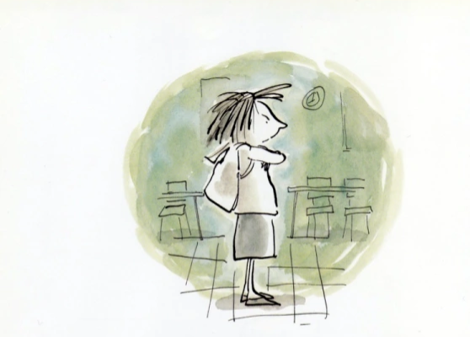
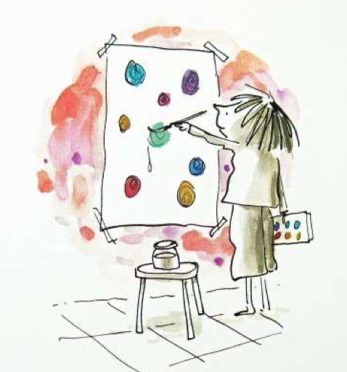
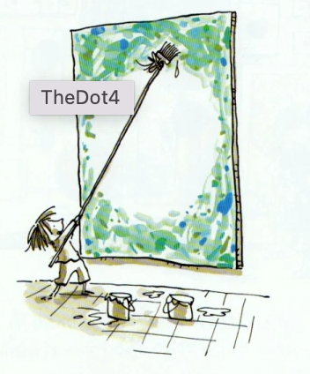
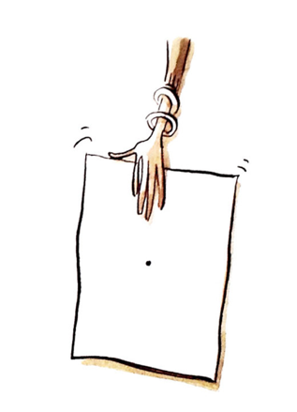
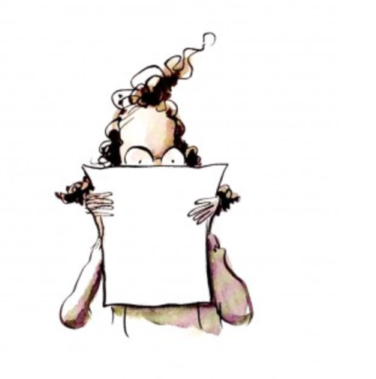
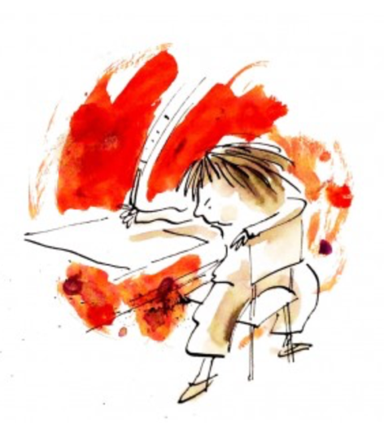
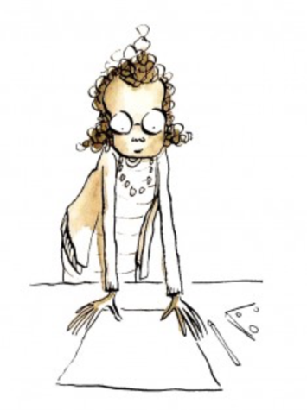

Vashti’s teacher smiled. Just make a mark and see where it takes you.

Vashti grabbed market and gave the paper a good strong jab. There!

Her teacher picked up the paper and looked at it carefully. ‘Hmmmmm!’ she thought.

She pushed the paper toward Vashti and quietly said, ‘Now, sign it!’

‘Hmmph. I can make a better dot than that’, Vashti thought.

Vashti even made a dot by not painting a dot.

Vashti painted more dots. She painted and painted. Blue dots, green dots, red dots, yellow dots, purple dots.

